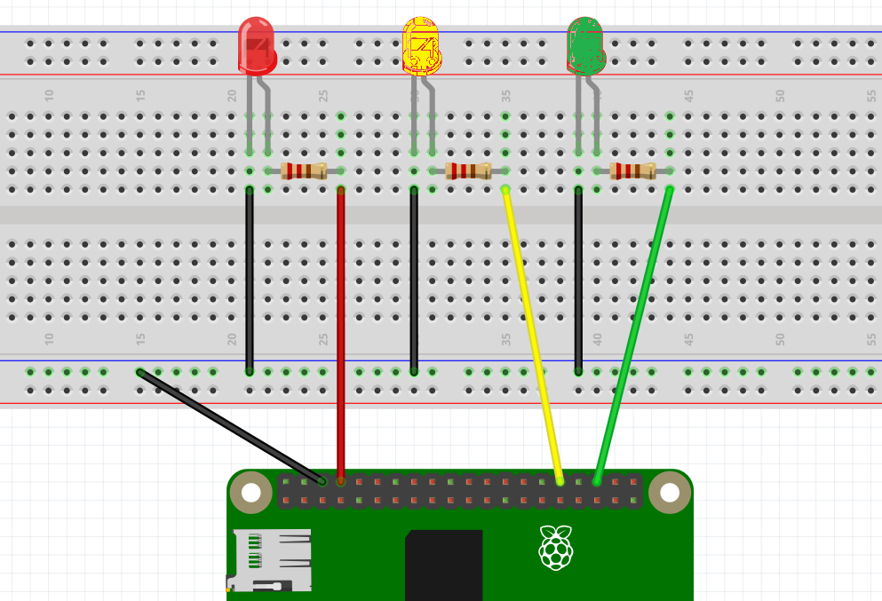

**-ve**

**+ve**

**Ground**

**Ground**

**Ground**

**Ground**

**Check your Pi Orientation!!**

**Please refer to your PIN Diagram**

**PIN 12**

**PIN 16**

**PIN 14**

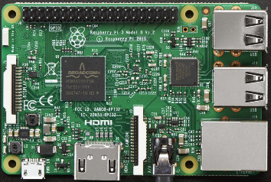

**TRAFFIC LIGHT**

**TRAFFIC LIGHT**

|  |  |
| --- | --- |
| EXERCISE :  THIS IS HOW A TRAFFIC LIGHT WORKS.   1. RED LIGHT ON 2. AFTER 20 SECONDS, RED LIGHT OFF, GREEN LIGHT ON 3. ALLOW TRAFFIC 15 SECONDS TO CROSS 4. GREEN LIGHT OFF 5. AMBER LIGHT COMES ON 6. ALLOW 15 SECONDS GRACE PERIOD 7. AMBER LIGHT GOES OFF 8. RED LIGHT COMES ON   TRY TO WRITE THE CODE YOURSELF USING THE HINT ABOVE  YOU NEED A while True: LOOP | Last week’s Patrolcar.py sample code  from gpiozero import LED  from time import sleep  red_led= LED(14)  blue_led = LED(12)  While True:  red_led.on()  sleep(.2)  red_led.off()  blue_led.on()  sleep(.2)  blue_led.off() |
| from gpiozero import LED  from time import sleep  led_red = LED(14)  …………  …………  while True:  led_red.on()  ………..  ……….  ……… |  |